# The AI Workforce Revolution: How Jobs, Teams, and Leadership Will Transform by 2045

The fear of artificial intelligence disrupting jobs has permeated modern workplaces, creating palpable tension as professionals brace for a seemingly inevitable wave of transformation. The narrative surrounding AI often hinges on uncertainty: Will my job vanish, evolve, or flourish under AI’s expansive reach?

While concerns about AI-driven job losses are not unfounded, current projections remain speculative. Nevertheless, experts suggest a profound shift ahead. For instance, within just five years, up to 30% of work hours in the US economy could potentially be automated, a shift accelerated by generative AI. Traditional entry-level and routine jobs, from customer service representatives and office support to certain food service roles, are most vulnerable. The implications are significant: junior staff, administrative assistants, and routine clerks may face displacement as AI rapidly assumes these basic tasks.

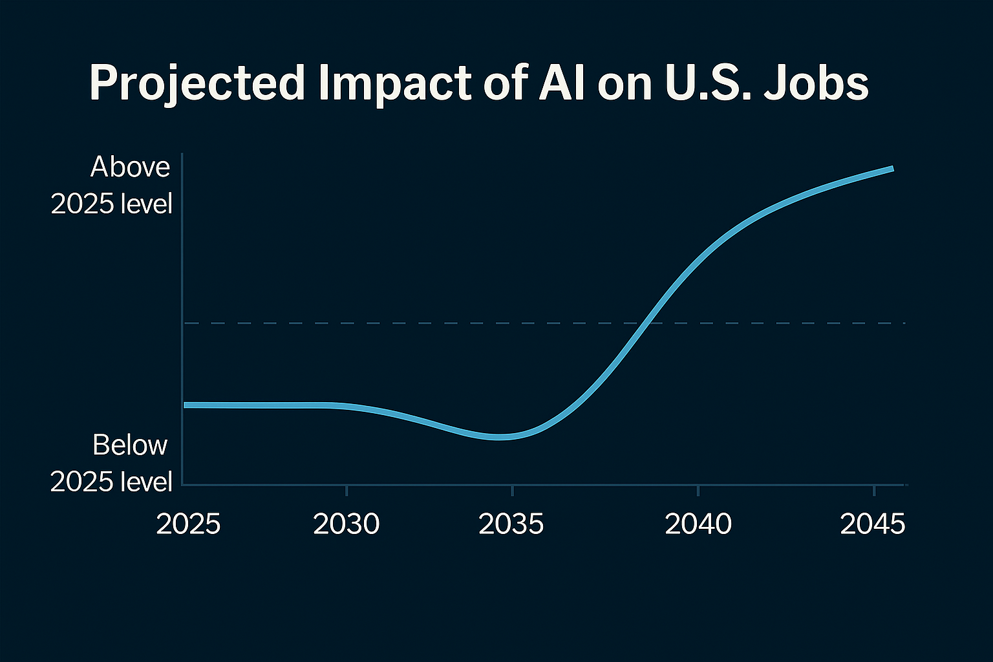

Yet, the narrative is not solely one of loss; rather, it is also one of remarkable potential. AI promises to augment roles, giving professionals unprecedented superpowers. Doctors, lawyers, engineers, and managers will increasingly rely on AI co-pilots for diagnostics, legal research, engineering solutions, and strategic insights. AI tools will liberate professionals from mundane, repetitive cognitive tasks, enabling them to dedicate their focus toward higher-level creative and interpersonal activities. Thus, rather than replacing human talent outright, AI will amplify its potential, fundamentally reshaping roles into hybrids of human judgment and artificial intelligence precision.

The transformation of white-collar jobs will be particularly profound. Generative AI technologies excel at analytical, administrative, and even creative tasks, redefining roles significantly. By the mid-2030s, approximately 18% of existing jobs in advanced economies such as the UK could face high automation risks, particularly affecting traditional retail cashiers, accounting clerks, and repetitive production line workers. Conversely, new roles in AI oversight, data science, and automation maintenance will emerge robustly, with healthcare, technology, and environmental sectors expanding employment opportunities significantly.

Meanwhile, blue-collar and vocational roles experience more gradual shifts. Robotics and automation, historically impacting manufacturing and logistics, are increasingly sophisticated due to AI-driven capabilities. Autonomous vehicles, for instance, could significantly disrupt transportation jobs by the late 2030s. Yet, roles requiring complex, real-world adaptability such as skilled trades, healthcare services, and education remain resilient, supported by AI tools rather than replaced outright. A graph of jobs and sectors impacts over time

As AI permeates deeper into the workforce, the very structure of teams will be transformed. Consider the digital twin: a virtual replica of an employee’s responsibilities and knowledge. In pioneering companies, executives are already mandated to maintain digital twins, which integrate emails, reports, and project data into a dynamic simulation of their professional roles. The result is radical transparency, eliminating traditional status meetings and the politics of corporate reporting. Each week, executives receive a candid, unbiased snapshot of company operations, enabling immediate, informed decisions. Board meetings become streamlined as AI-driven twins provide instant analysis, removing months-long research cycles.

This sophisticated AI integration extends beyond internal operations to real-time market analysis and supply chain optimization. Imagine logistics firms rerouting supply chains instantly in response to geopolitical shifts, or financial institutions adjusting investment strategies dynamically based on AI-driven economic forecasting. The unprecedented immediacy and clarity provided by AI not only enhance decision-making but also dramatically elevate executive accountability and strategic agility.

The restructuring of the workweek itself represents another significant transformation. AI-driven productivity gains enable businesses to reconsider traditional scheduling norms fundamentally. Trials conducted in the UK with four-day workweeks have already demonstrated stable or improved productivity alongside enhanced employee satisfaction and reduced burnout. As AI increasingly supports asynchronous and remote collaboration, particularly within knowledge-based industries, flexible working arrangements could become widespread. Traditional nine-to-five routines may yield to fluid, globally distributed, task-based workflows, enhancing work-life balance and operational efficiency alike.

The potential adoption of Universal Basic Income (UBI) also arises prominently within this shifting landscape. Pilot studies from Finland, the Netherlands, and the United States indicate promising outcomes, such as improved mental well-being, reduced stress, and even increased labor participation under less restrictive welfare conditions. As AI potentially diminishes traditional employment opportunities, particularly in entry-level positions, UBI or related income-support measures may transition from experimental to essential social policy components, underpinning economic stability during significant workforce disruptions.

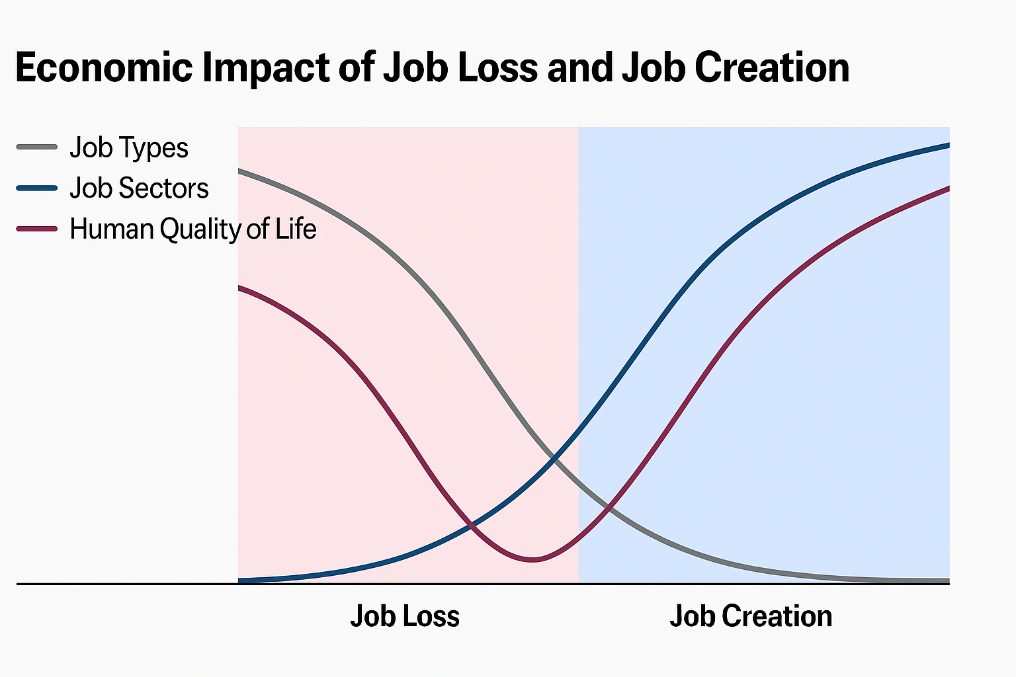

The role of entry-level positions, historically the foundation for professional skill development and career advancement, faces particular scrutiny. AI’s capabilities in automating routine junior tasks threaten to create a critical gap in professional development pathways. Businesses and educational institutions must innovate proactively, establishing new training paradigms such as AI-assisted apprenticeships or simulation-based skill development. This strategic shift could enable entry-level workers to bypass rote tasks, quickly acquiring advanced competencies necessary for roles increasingly defined by their interactions with sophisticated AI tools.

Digital twin technology presents an especially powerful approach to workforce training and optimization. This technology allows realistic, risk-free training across multiple sectors from healthcare professionals performing virtual surgeries to project managers optimizing workflows in simulated environments. These virtual models not only enhance individual skillsets rapidly and safely but also serve as powerful tools for organizational planning and decision-making. For example, digital twins can model complex operational scenarios, such as supply chain disruptions or cybersecurity breaches, enabling teams to prepare effectively through realistic practice and proactive strategy adjustments.

For leadership teams, AI promises unparalleled information access and responsiveness. CEOs and senior leaders will operate with a depth of real-time data previously unimaginable, directly engaging with sophisticated AI models to interrogate company performance, market trends, and competitive landscapes without intermediaries. The informed leadership empowered by AI will make strategic decisions with pinpoint precision and responsiveness, driving competitive advantage and corporate resilience.

Ultimately, the AI-driven future calls for substantial cultural evolution. The nature of work, identity, and societal value must shift beyond traditional frameworks of employment. As mundane tasks become automated, humans will increasingly engage in work characterized by creativity, strategic problem-solving, interpersonal communication, and empathy-driven services. Societies must collectively redefine success, embracing opportunities outside conventional employment, such as community involvement, artistic pursuits, and personal development.

In conclusion, the future of work is not merely about surviving AI-driven disruption, it is about harnessing it. AI presents a powerful tool for human empowerment, redefining roles, enhancing productivity, and cultivating deeper, more authentic customer relationships. The workplaces of tomorrow, buoyed by human-AI collaboration, offer extraordinary promise: enhanced human capability, innovative work models, and richer human experiences, underscoring that the journey toward AI integration, though complex, holds unparalleled potential for those prepared to embrace it.